**Physical appearance data - Birds**

**Colours**

**Record:** Score

Black, white, red, pink, orange, yellow-orange, yellow, yellow-green, green, blue-green, blue, blue-violet, violet, red-violet, brown

For body, wings, tail and bare skin on face or neck

1= dark  
2= dull  
3= light  
4= mid (standard)  
5= bright   
6= iridescent

Black= 1 or 6  
White= 1

**Overall Impression**

**Record:** Presence as 1, exclusive categories

Plain: all or practically all one colour (including iridescent eg. Entirely iridescent black)   
Bicolour: Wings vs. body= wings (and often tail) are differently coloured to body  
Bicolour: Ventral vs. dorsal= differently coloured along spine vs along belly  
Bicolour: Upper vs. lower= differently coloured upper and lower sections of body  
Tricolour or more= multiple shades or colours without overriding overall impression

Some have been left blank if unsure about category

Prominent patches= mark 1 if any notable patches, eg. Sharp contrast, bright or unusual colours. Additional to overall impression, not exclusive.

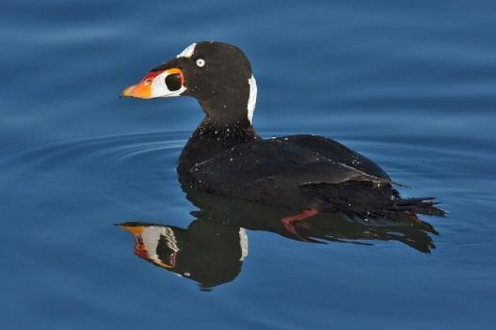**Examples of difficulties:**

Surf scoter= plain as almost entirely black, white parts can be marked under prominent patches

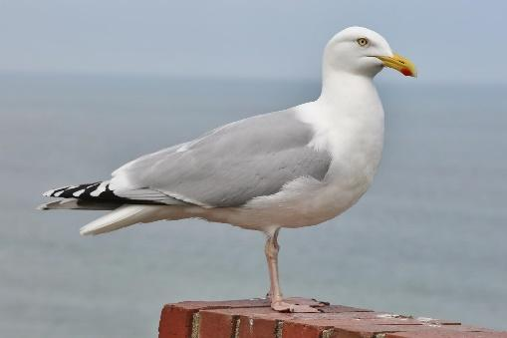

Herring gull= wings vs. body, technically tricolour (white, grey and black) but overall impression is of wings vs body, black is from wing tips

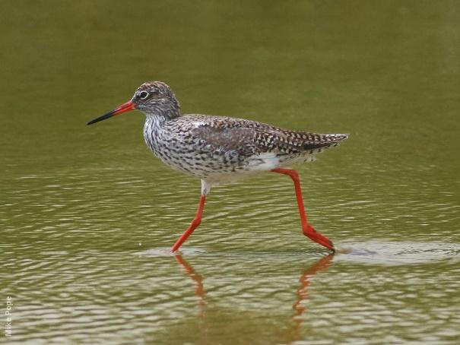

Common redshank= ventral vs. dorsal, streaky but overall impression is brown dorsal, white ventral

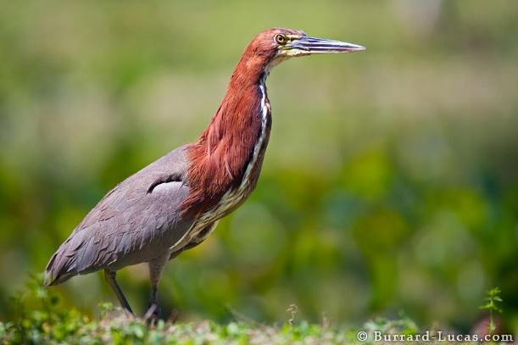

Rufescent tiger heron= upper vs. lower, white stripe is a pattern feature rather than large area of colour

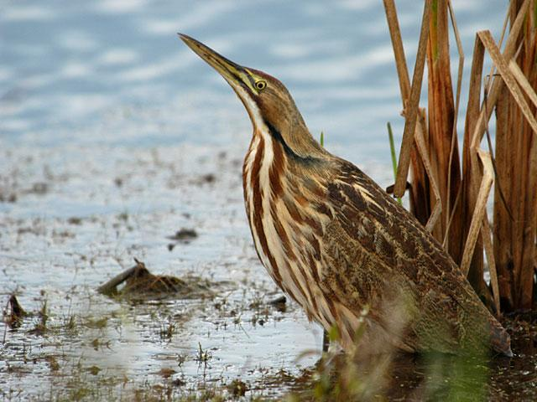

American bittern= tricolour or more, multiple shades of brown, black and white, streaks override ventral vs dorsal impression

**Patterning**

**Record:** Presence as 1

Vermiculation= fine stripes or patterns  
Spotted= larger spots  
Speckled= fine spots  
Body streaking/striping= thicker lines or splotches than vermiculation

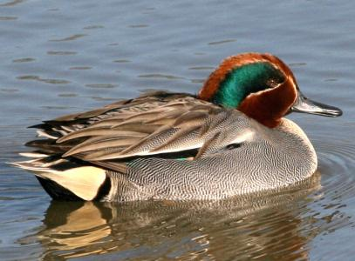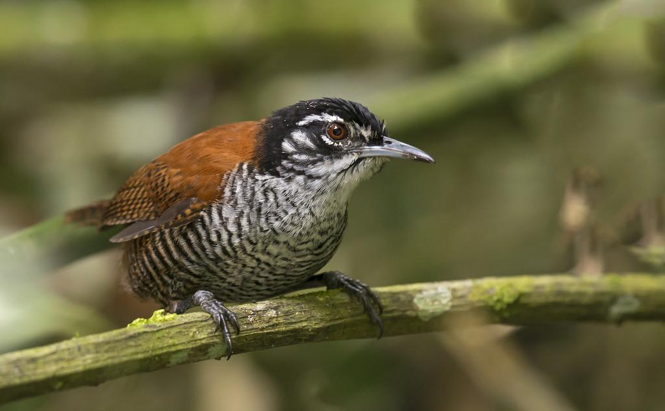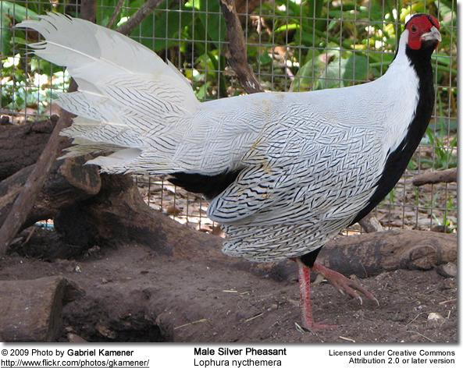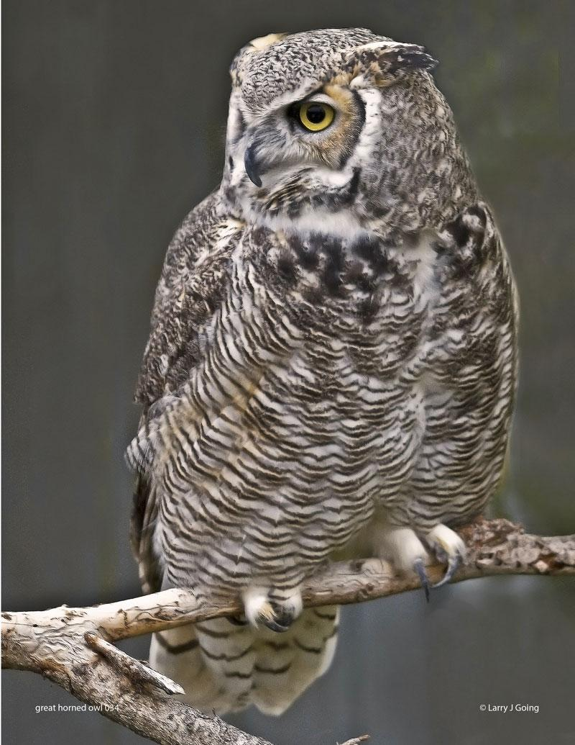Vermiculation examples:

← May have both streaking and vermiculation, bay wren has streaky face

**Head patterning**

**Record:** Presence as 1

Includes patches, stripes, spots, etc. also counts as 1 if head is noticeably different colour to rest of body. Specific to head, eg. If entire bird is speckled, does not count as head patterning.  
A crest alone does not count as head patterning, would need to be differently coloured or patterned from rest of head.

**Crest on head**

**Record:** size (small, medium, large) then colour

Small= smaller than head  
Medium= approx. same size as head  
Large= larger than head

If particularly unusual appearance, could also mention in unusual adornments.  
Owl ear tufts mentioned in unusual adornments, not counted as crest.

**Other unusual adornments**

**Record:** Write any features that might make a bird’s appearance stand out to a tourist

Includes wattle, ornamental feathers, whiskers, obvious eye rings, brightly coloured eyes that stand out, unusual bill shape, patches on bill, etc.

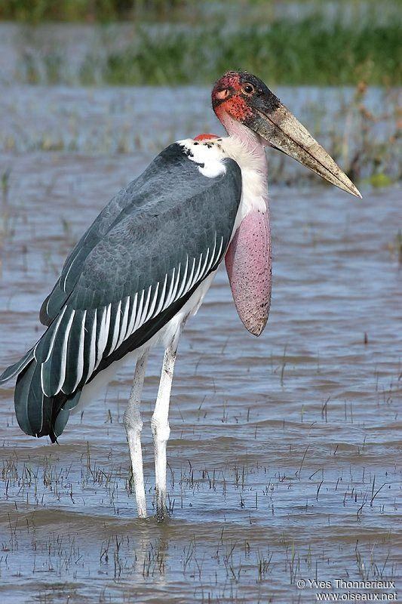

Some examples:

**Gular pouch (gular sac/throat pouch):** bare skin connecting the beak to the neck, most obvious in pelicans and frigatebirds. Not the same as a wattle, which is an external fleshy growth rather than a pouch.

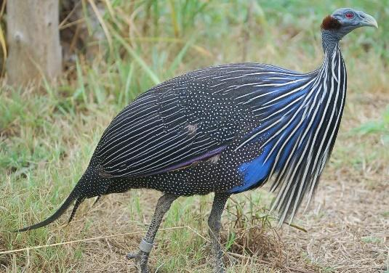

**Hackles:** Long neck feathers

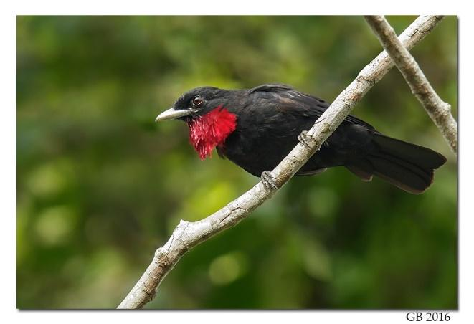**Gorget:** Colourful patch of feathers on throat, mostly seen in hummingbirds

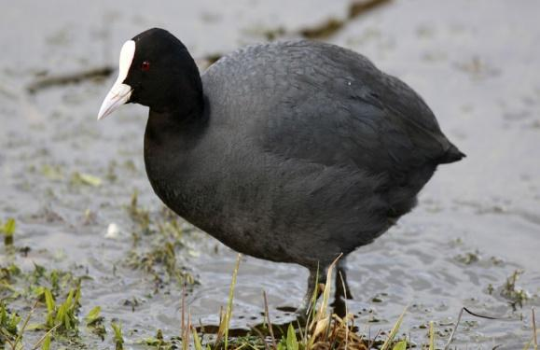

**Frontal shield:** Rounded knob on forehead extending above bill

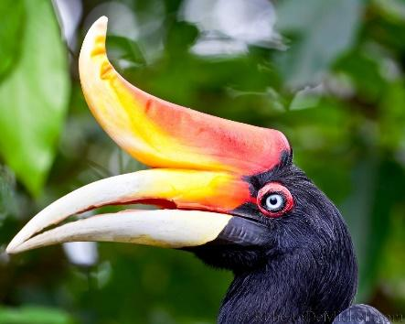

**Casque:** enlarged structure on head or beak

**Notes**

**Record:** Any other information worth mentioning eg. If female is more brightly coloured, if there are very different colour morphs

**Appendages**

(Body length not including tail or neck)

**Bill Length**

**Record:** Score

1=short (less than half head length)  
2=medium (half head length to approx. head length)  
3=long (more than half body length)   
4=very long (approx. body length or longer)

**Bill Type**

**Record:** Score

1=very broad e.g. Toucans, adjutants  
2=broad e.g. Penguins, shovelers   
3=medium e.g. Herons  
4=thin e.g. Hummingbirds (unless curved)   
5=thin and curved e.g. Avocets, sunbirds   
6=curved e.g. Ibis  
7=hooked e.g. Parrots, birds of prey  
8=spoon e.g. Spoonbills

**Bill Colour**

**Record:** Write colour, use majority colour unless no majority/obviously multicoloured

**Tail length**

**Record:** Score

1=short (less than half body length)   
2=medium (approx. half body length)  
3=long (approx. body length)   
4=very long (longer than body length)   
5=very long and fancy (longer than body length with particularly ornamental feathers)

**Exposed leg length**

**Record:** Score

1=short (less than half body length  
2=medium (approx. half body length)   
3=long (more than half body length)   
4=very long (body length or longer)

**Leg Colour**

**Record:** Write colour, use majority colour unless no majority/obviously multicoloured